DSA LAB 4 TASKS
NAME: MUHAMMAD ANAS | ID: 25K-0577 | SECTION: BCS-3A

Q1:
CODE:
#include <iostream>
using namespace std;

class Node{
public:
int data;
Node* next;

Node(int val){
data = val;
next = NULL;
}
};

class SL{
Node* head;
Node* tail;

public:
SL(){
head = tail = NULL;
}

void insertBeg(int val){
Node* newnode = new Node(val);
if(head == NULL){
head = tail = newnode;
}
else{
newnode->next = head;
head = newnode;
}
}

void display(){
Node* temp = head;
while(temp != NULL){
cout << temp->data << " ";
temp = temp->next;
}
cout << endl;
}
};

int main(){
SL s;
cout << "Enter 3 values: ";
for(int i=1; i<=3; i++){
int x;
cin >> x;
s.insertBeg(x);
}

s.display();
}

OUTPUT:
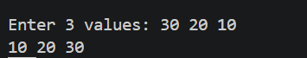

Q2:
CODE:
#include <iostream>
using namespace std;

class Node{
public:
int data;
Node* next;

Node(int val){
data = val;
next = NULL;
}
};

class SL{
Node* head;
Node* tail;

public:
SL(){
head = tail = NULL;
}

void insertBeg(int val){
Node* newnode = new Node(val);
if(head == NULL){
head = tail = newnode;
}
else{
newnode->next = head;
head = newnode;
}
}

void insertEnd(int val){
Node* newnode = new Node(val);
if(head==NULL){
head = tail = newnode;
}
else{
tail->next = newnode;
tail = newnode;
}
}

void display(){
Node* temp = head;
while(temp != NULL){
cout << temp->data << " ";
temp = temp->next;
}
cout << endl;
}
};

int main(){
SL s;
cout << "Enter 3 values: ";
for(int i=1; i<=3; i++){
int x;
cin >> x;
s.insertBeg(x);
}

cout << "Enter 2 values: ";
for(int i=1; i<=2; i++){
int x;
cin >> x;
s.insertEnd(x);
}

s.display();
}

OUTPUT:
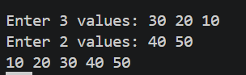

Q3:
CODE:
#include <iostream>
using namespace std;

class Node{
public:
int data;
Node* next;

Node(int val){
data = val;
next = NULL;
}
};

class SL{
Node* head;
Node* tail;

public:
SL(){
head = tail = NULL;
}

void insertBeg(int val){
Node* newnode = new Node(val);
if(head == NULL){
head = tail = newnode;
}
else{
newnode->next = head;
head = newnode;
}
}

void insertEnd(int val){
Node* newnode = new Node(val);
if(head==NULL){
head = tail = newnode;
}
else{
tail->next = newnode;
tail = newnode;
}
}

void insertPos(int val, int pos){
if(pos<1){
cout << "Invalid pos";
return;
}
if(pos==1){
insertBeg(val);
return;
}

Node* curr = head;
Node* pre;
for(int i=1; i<pos; i++){
if(curr==NULL) return;
pre = curr;
curr = curr->next;
}

Node* newnode = new Node(val);
pre->next = newnode;
newnode->next = curr;
if(curr==NULL){
tail = curr;
}
}

void display(){
Node* temp = head;
while(temp != NULL){
cout << temp->data << " ";
temp = temp->next;
}
cout << endl;
}
};

int main(){
SL s;

cout << "Enter 5 values: ";
for(int i=1; i<=5; i++){
int x;
cin >> x;
s.insertEnd(x);
}

s.display();

int pos, x;
cout << "Enter a position: ";
cin >> pos;
cout << "Enter a value: ";
cin >> x;
s.insertPos(x, pos);
s.display();

}

OUTPUT:
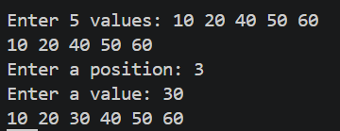

Q4:
CODE:
#include <iostream>
using namespace std;

class Node{
public:
int data;
Node* next;

Node(int val){
data = val;
next = NULL;
}
};

class SL{
Node* head;
Node* tail;

public:
SL(){
head = tail = NULL;
}

void insertBeg(int val){
Node* newnode = new Node(val);
if(head == NULL){
head = tail = newnode;
}
else{
newnode->next = head;
head = newnode;
}
}

void insertEnd(int val){
Node* newnode = new Node(val);
if(head==NULL){
head = tail = newnode;
}
else{
tail->next = newnode;
tail = newnode;
}
}

void insertPos(int val, int pos){
if(pos<1){
cout << "Invalid pos";
return;
}
if(pos==1){
insertBeg(val);
return;
}

Node* curr = head;
Node* pre;
for(int i=1; i<pos; i++){
if(curr==NULL) return;
pre = curr;
curr = curr->next;
}

Node* newnode = new Node(val);
pre->next = newnode;
newnode->next = curr;
if(curr==NULL){
tail = curr;
}
}

void search(int key){
Node* temp = head;
while(temp != NULL){
if(temp->data == key){
cout << "Value Found in the list" << endl;
return;
}
temp = temp->next;
}
cout << "Value Not Found in the list" << endl;
}

void display(){
Node* temp = head;
while(temp != NULL){
cout << temp->data << " ";
temp = temp->next;
}
cout << endl;
}
};

int main(){
SL s;

cout << "Enter 5 values: ";
for(int i=1; i<=5; i++){
int x;
cin >> x;
s.insertEnd(x);
}

int key;
cout << "Enter value to search in the list: ";
cin >> key;
s.search(key);

s.display();

}

OUTPUT:
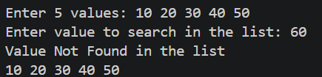

Q5:
CODE:
#include <iostream>
using namespace std;

class Node{
public:
int data;
Node* next;

Node(int val){
data = val;
next = NULL;
}
};

class SL{
Node* head;
Node* tail;

public:
SL(){
head = tail = NULL;
}

void insertBeg(int val){
Node* newnode = new Node(val);
if(head == NULL){
head = tail = newnode;
}
else{
newnode->next = head;
head = newnode;
}
}

void insertEnd(int val){
Node* newnode = new Node(val);
if(head==NULL){
head = tail = newnode;
}
else{
tail->next = newnode;
tail = newnode;
}
}

void insertPos(int val, int pos){
if(pos<1){
cout << "Invalid pos";
return;
}
if(pos==1){
insertBeg(val);
return;
}

Node* curr = head;
Node* pre;
for(int i=1; i<pos; i++){
if(curr==NULL) return;
pre = curr;
curr = curr->next;
}

Node* newnode = new Node(val);
pre->next = newnode;
newnode->next = curr;
if(curr==NULL){
tail = newnode;
}
}

void deleteStart(){
if(head == NULL) return;
if(head == tail){
delete head;
head = tail = NULL;
return;
}
Node* temp = head;
head = head->next;
delete temp;
}

void deleteEnd(){
if(head == NULL) return;
if(head == tail){
delete head;
head = tail = NULL;
return;
}
Node* temp = head;
while(temp->next != tail){
temp = temp->next;
}
delete tail;
tail = temp;
tail->next = NULL;
}

void deletePos(int pos){
if(pos<1){
cout << "Invalid pos";
return;
}
if(pos==1){
deleteStart();
return;
}
Node* curr = head;
Node* pre;
for(int i=1; i<pos; i++){
if(curr == NULL) return;
pre = curr;
curr = curr->next;
}

if (curr == NULL) {
cout << "Position out of bounds";
return;
}

if (curr == tail) {
tail = pre;
}

pre->next = curr->next;
curr->next = NULL;
delete curr;

}

void display(){
Node* temp = head;
while(temp != NULL){
cout << temp->data << " ";
temp = temp->next;
}
cout << endl << endl;
}
};

int main(){
SL s;

cout << "Enter 7 values: ";
for(int i=1; i<=7; i++){
int x;
cin >> x;
s.insertEnd(x);
}
s.display();

cout << "Deleting at End" << endl;
s.deleteEnd();
s.display();

cout << "Deleting at Start" << endl;
s.deleteStart();
s.display();

int pos;
cout << "Enter a position: ";
cin >> pos;
s.deletePos(pos);
s.display();

}

OUTPUT:

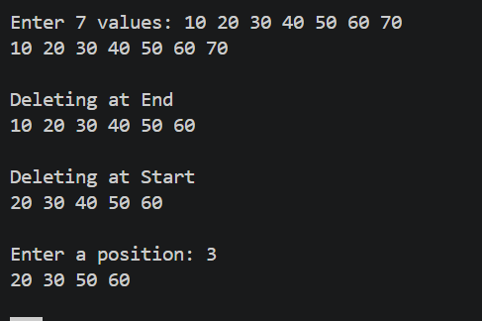

Q6:
CODE:

